Prestashop module for Layer Payment

for Prestashop 1.7

Caution: Always keep backup of your existing Prestashop installation including Mysql Database, before installing a new module.

Install Module:-

1. Copy the folder ‘layerpayment’ from this zip and paste/upload it to ‘<prestashop root>\modules’ folder.

Configure Module:-

1. Login to Prestahop admin and open Modules->Module Catalog. Type ‘Layer’ in search and search.

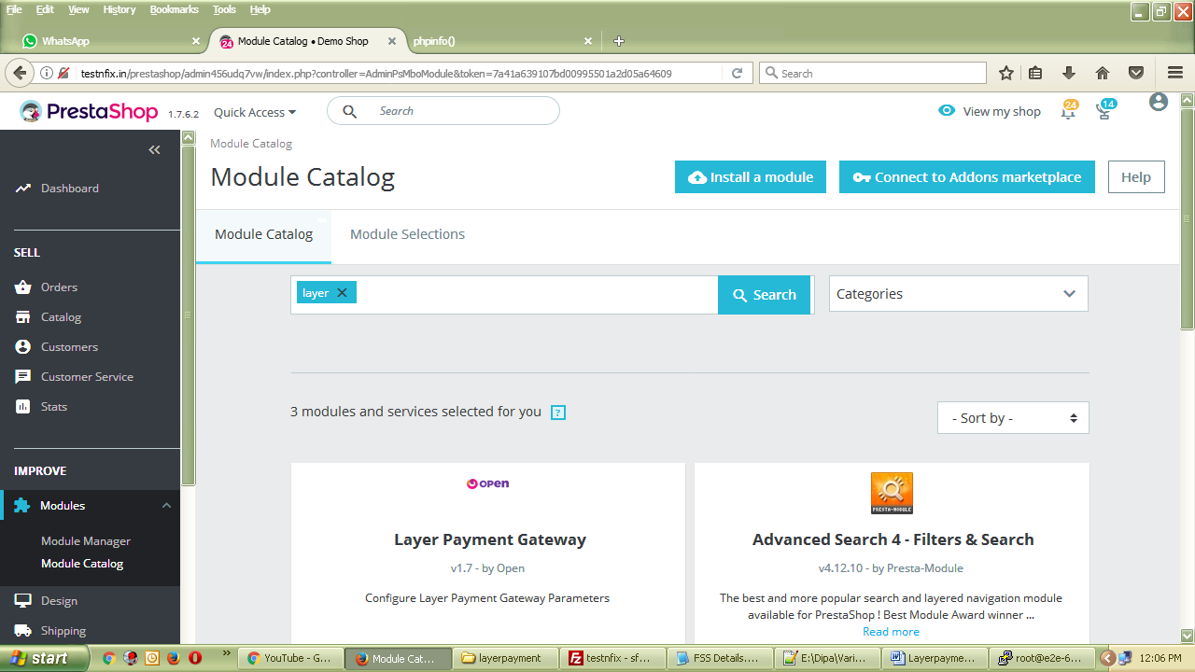

1. Click on ‘Install’ below module description.

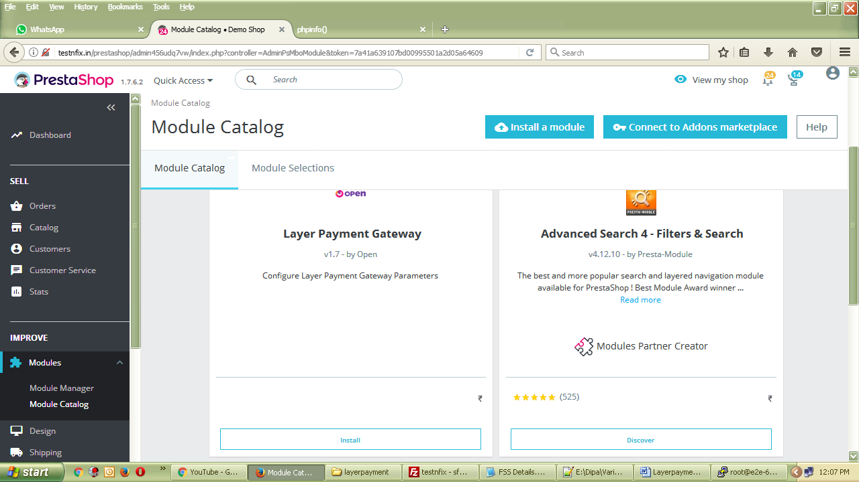

3. Configure the module by filling up appropriate credentials.

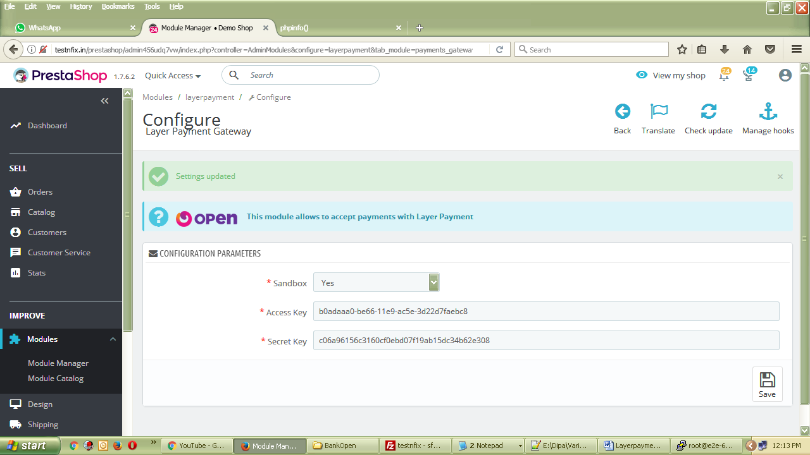

1. To modify configuration, visit Modules -> Module Manager and search for ‘Layer
2. To modify payment preferences, visit Payment -> Preferences
3. Save/Update settings and customer will get Layer Payment option during checkout process.